Desktop & Tablet Version:

* Logo is wrong. Use the provided SVG file. Top logo size should be 150px x 150px.ok
* Name of university in English and Arabic should match the live site. English font is Open Sans and Arabic is Neue Helvetica Arabic. It is already?
* The top most bar should also be as wide as the page itself. It will not have any menu item. Its color is #320F14 with opacity of 100%. CR
* The second bar has color #4B121B with opacity of 100%. Already
* The semi-transparent bar (3rd from top) has color #8B0000 with opacity of 85%. In design opacity was 80%
* Menu should have gray color slightly semi-transparent background. Menu size should not be larger than slides (should not cover more than the slides when open). Column headings should have color #4B121B and items should have color #320F14. Items should be distinguishable from each other possibly through underlines or any other suitable separator. bigger CR
* Menu button should be next to the logo in the semi-transparent bar. Word menu should not be used. Only symbol should be provided. CR
* The text overlay of the slides should look like the following: CR

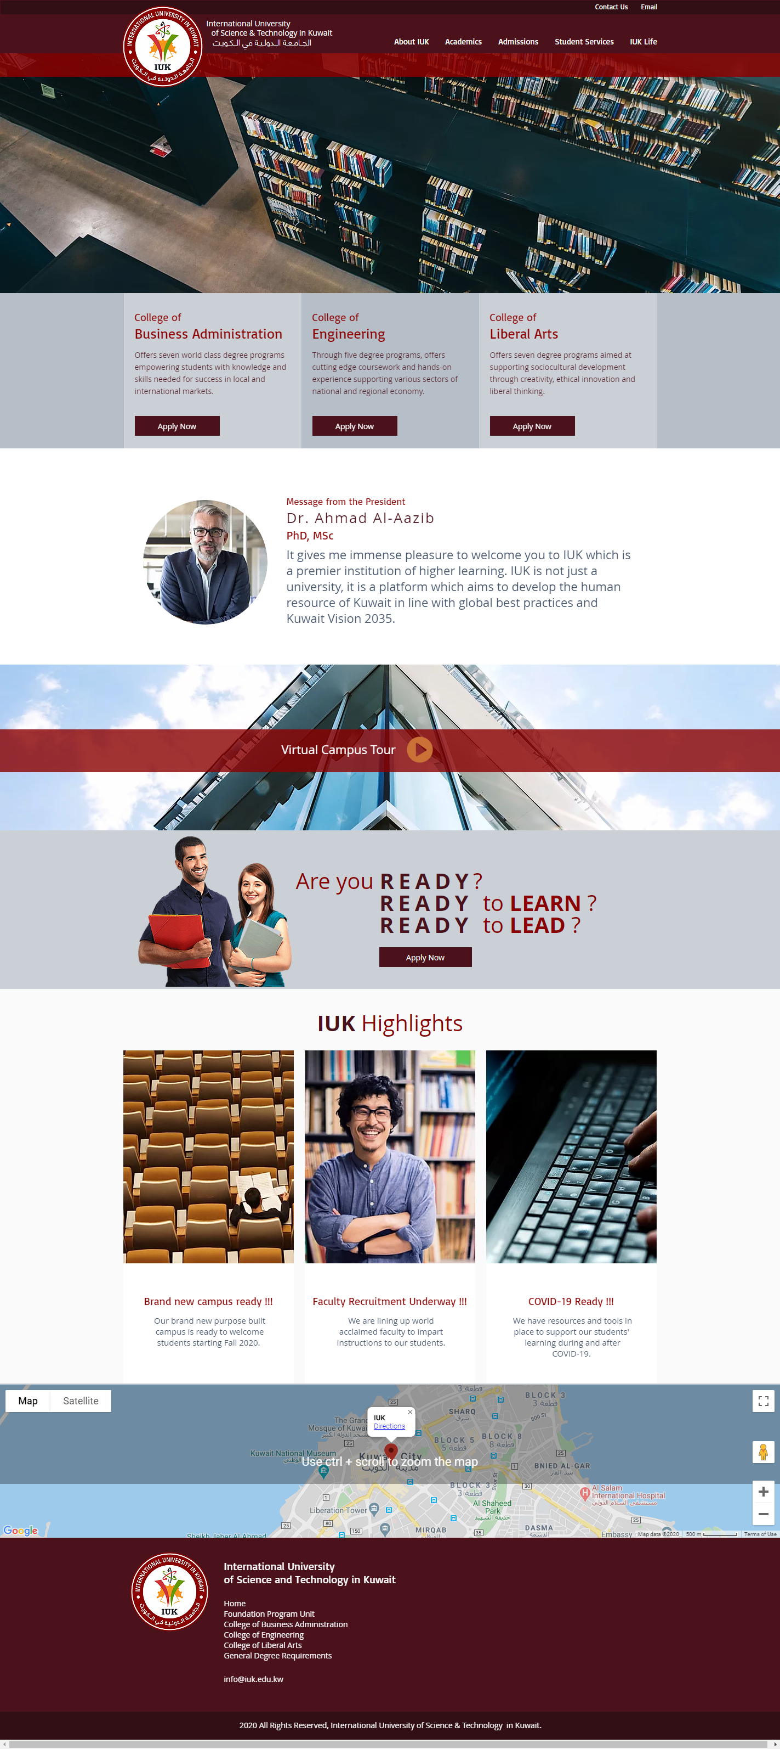

* Slide text overlay should not be wider than half of the visible slide size. The Read More button should be next to it. The size of the Read More button should be similar to Apply Now buttons in the three column containers. Text should be white for both the button and overlay. Font size should be 14px, font Open Sans. Ensure all font files are embedded in the website to allow consistent look and feel on all devices. CR
* Font of the headings in the three-column container is Basic, size 20px for first row and 26px for second row. If Basic is not available, replace it with Cambria. Ensure all font files are embedded in the website to allow consistent look and feel on all devices. already
* Font of the text in the three-column container is Open Sans, size 14. already
* The height of all strips should match the current live site. Current live site url?
* For the message of President, use the three-line heading as follows: CR
  + First row, Basic/Cambria, size 14px
  + Second row, Basic/Cambria, size 26px
  + Third row, Basic/Cambria, size 22px
* For message of President, text will be Open Sans, size 22px. Slightly increase the space between the image and paragraph. CR
* Read More should be in the form of a button. CR
* Virtual Campus Tour should replicate the current live site in terms of image, height and overlay color. The round button can be replaced with a button having color matching one of the maroon shades used on the site with a while triangle in the middle. This button should be a vector graphic (preferably SVG). CR
* The text in the Ready strip should use fonts mentioned above (Open Sans, Basic/Cambria). Image of students should be aligned to the bottom of the strip. ok
* Height of Teach should be same as the Ready strip. Button should be same. Image should be on the right side and background of the strip should be gray (the darker one in the three-column container. CR
* Height of next strip should be higher with reasonable font size and placement. ok
* IUK Highlight heading size, color and bold/not bold should match the current live site. Just change the font to Basic/Cambria. Ok
* Change the highlights to match the current layout on the live site. Add Read More buttons at the bottom of each item. CR
* Reach Us heading size, color and bold/not bold and font should match IUK Highlights as mentioned above. ok….
* Remove the subscription bar. Add a small overlay to the map which would have the address given in Open Sans. The layout of the overlay is shown below: CR



* More menu items will be added to footer so reduce the size of social media icons and use font awesome elements instead of images. Icons should be included for Facebook, LinkedIn, Twitter, YouTube, Snap Chat and Instagram. It is already font awesome elements but will reduce size
* Text in the lowest footer bar should be vertically centered in the bar. Text should be in Open Sans. CR